CHARACTERS
Level 19 (Syndicate Mountain Compound)
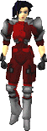 | Name:  Model:  Health:  Team:  Lose Func: | GrifElite03  red_hard_1  138  Syndicate  check_death1a | 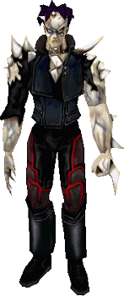 | Name:  Model:  Health:  Team:  Name:  Model:  Health:  Team:  Lose Func: | muro_dummy  mutantmuro  406  Syndicate  MutantMuro  mutantmuro  406  Syndicate  Outro
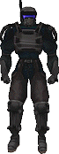 | Name:  Model:  Health:  Team:  Drops:  Lose Func: | GrifOps03  TCTF_swat_blackops_1  90  Konoko  1 hypo  swat_dies
 | Name:  Model:  Health:  Team:  Drops:  Lose Func: | GrifOps02  TCTF_swat_blackops_1  90  Konoko  1 hypo  swat_dies | 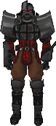 | Name:  Model:  Health:  Team:  Lose Func: | GrifElite01  elite_hard_1  200  Syndicate  check_death1
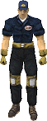 | Name:  Model:  Health:  Team:  Drops:  Hit Func: | ParkStriker  thug_wh_1  31  Syndicate  1 hypo  driverhurt | 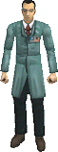 | Name:  Model:  Health:  Team:  Drops: | B_N1  bd_2  100  SyndicateAccessory  1 hypo
 | Name:  Model:  Health:  Team: | B_N2  bd_2  100  SyndicateAccessory | 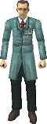 | Name:  Model:  Health:  Team:  Gives: | B_N3  bd_5  100  SyndicateAccessory  1 hypo
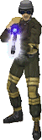 | Name:  Model:  Health:  Team:  Weapon:  Has: | A_S1  sniper_generic  38  Syndicate  w8_mbo  10 ammos | 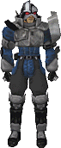 | Name:  Model:  Health:  Team: | A_E3  elite_med_1  125  Syndicate
 | Name:  Model:  Health:  Team:  Weapon: | A_S2  sniper_generic  38  Syndicate  w8_mbo | 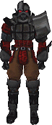 | Name:  Model:  Health:  Team: | A_E4  elite_med_2  150  Syndicate
 | Name:  Model:  Health:  Team:  Drops: | A_E5  elite_med_3  125  Syndicate  1 hypo | 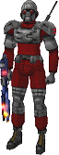 | Name:  Model:  Health:  Team:  Weapon:  Hit Func: | A_Sb7  striker_med_3  56  Syndicate  w3_phr  run1
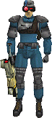 | Name:  Model:  Health:  Team:  Weapon:  Has: | A_Sb8  striker_med_3  69  Syndicate  w7_scc  1 ammo | 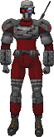 | Name:  Model:  Health:  Team:  Weapon: | B_Sr9  striker_hard_2  88  Syndicate  none
 | Name:  Model:  Health:  Team: | B_Eb11  elite_med_1  125  Syndicate | 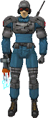 | Name:  Model:  Health:  Team:  Weapon: | A_E6b  striker_med_2  69  Syndicate  w6_vdg
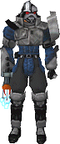 | Name:  Model:  Health:  Team:  Weapon:  Has: | B_Esb15  elite_med_2  125  Syndicate  w6_vdg  1 ammo | 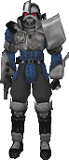 | Name:  Model:  Health:  Team:  Weapon:  Has: | B_Eb16  elite_med_2  125  Syndicate  w2_sap  1 ammo
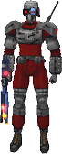 | Name:  Model:  Health:  Team:  Weapon:  Drops: | C_Sr17  striker_hard_2  88  Syndicate  w3_phr  1 hypo | 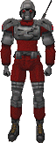 | Name:  Model:  Health:  Team:  Weapon: | C_Sr18  striker_hard_1  56  Syndicate  none
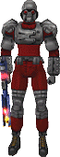 | Name:  Model:  Health:  Team:  Weapon: | C_Sr19  striker_hard_3  88  Syndicate  w3_phr | 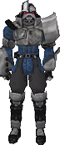 | Name:  Model:  Health:  Team: | C_Tb20  elite_med_2  125  Syndicate
 | Name:  Model:  Health:  Team:  Drops: | C_Eb21  elite_med_1  125  Syndicate  1 hypo | 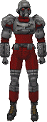 | Name:  Model:  Health:  Team:  Weapon:  Drops: | C_Eb22  striker_hard_3  88  Syndicate  none  1 ammo
 | Name:  Model:  Health:  Team:  Weapon: | C_Sb26  striker_hard_1  56  Syndicate  none | 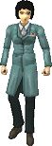 | Name:  Model:  Health:  Team:  Gives: | C_N23  bdfem_2  100  SyndicateAccessory  1 hypo
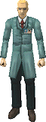 | Name:  Model:  Health:  Team:  Gives: | C_N24  bd_3  100  SyndicateAccessory  1 hypo |  | Name:  Model:  Health:  Team: | C_Sb25  striker_hard_3  88  Syndicate
 | Name:  Model:  Health:  Team: | C_Eb29  elite_med_1  125  Syndicate | 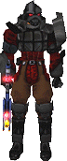 | Name:  Model:  Health:  Team:  Weapon:  Drops: | C_Eb27  elite_hard_2  150  Syndicate  w3_phr  1 hypo
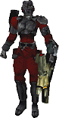 | Name:  Model:  Health:  Team:  Weapon: | C_Tr28  ninja_hard_3  81  Syndicate  w7_scc |  | Name:  Model:  Health:  Team:  Weapon: | C_Eb30  elite_med_3  150  Syndicate  none
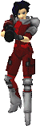 | Name:  Model:  Health:  Team:  Weapon: | D_R31  red_hard_1  75  Syndicate  w9_scr | 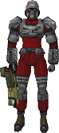 | Name:  Model:  Health:  Team:  Weapon: | D_R32  striker_hard_3  88  Syndicate  w7_scc
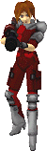 | Name:  Model:  Health:  Team:  Weapon: | D_R33  red_hard_3  75  Syndicate  w9_scr | 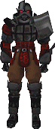 | Name:  Model:  Health:  Team:  Drops: | E_Er34  elite_hard_3  150  Syndicate  1 hypo
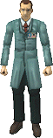 | Name:  Model:  Health:  Team:  Gives: | E_N35  bd_4  100  SyndicateAccessory  2 hypos |  | Name:  Model:  Health:  Team:  Gives: | E_N36  bd_4  100  SyndicateAccessory  2 hypos
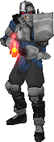 | Name:  Model:  Health:  Team:  Weapon: | E_Eb35  elite_med_1  125  Syndicate  w3_phr | 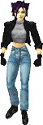 | Name:  Model:  Health:  Team:  Lose Func: | char_0  k4_K  200  Konoko  you_lose
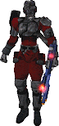 | Name:  Model:  Health:  Team:  Weapon: | E_Nr36  ninja_hard_1  81  Syndicate  w3_phr | 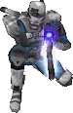 | Name:  Model:  Health:  Team:  Weapon: | E_Nb37  ninja_med_1  69  Syndicate  w8_mbo
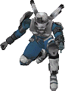 | Name:  Model:  Health:  Team:  Weapon: | E_Nb38  ninja_med_1  69  Syndicate  w2_sap | 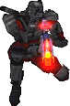 | Name:  Model:  Health:  Team:  Weapon:  Has: | E_Nr39  ninja_hard_1  81  Syndicate  w3_phr  2 ammos
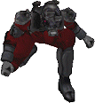 | Name:  Model:  Health:  Team:  Drops: | E_Tr40  ninja_hard_2  81  Syndicate  1 hypo |  | Name:  Model:  Health:  Team:  Gives: | E_N41  bd_3  100  SyndicateAccessory  1 hypo
 | Name:  Model:  Health:  Team:  Gives: | E_N42  bd_5  100  SyndicateAccessory  1 hypo |  | Name:  Model:  Health:  Team:  Gives: | E_N43  bd_3  100  SyndicateAccessory  1 hypo
 | Name:  Model:  Health:  Team:  Gives: | E_N44  bd_5  100  SyndicateAccessory  1 hypo | 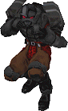 | Name:  Model:  Health:  Team:  Drops: | E_Er45  elite_hard_1  150  Syndicate  1 hypo
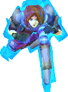 | Name:  Model:  Health:  Team:  Has:  Drops: | E_R46  red_hard_3  75  Syndicate  1 shield  1 shield  1 hypo | 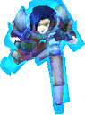 | Name:  Model:  Health:  Team:  Has:  Drops: | E_Nr46  red_hard_3  75  Syndicate  1 shield  1 shield  1 hypo
 | Name:  Model:  Health:  Team:  Drops: | S_Tr41  elite_hard_1  150  Syndicate  1 hypo |  | Name:  Model:  Health:  Team:  Weapon:  Drops: | F_Eb43  elite_med_1  125  Syndicate  w3_phr  1 cell
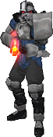 | Name:  Model:  Health:  Team:  Weapon:  Drops: | F_Eb44  elite_med_2  125  Syndicate  w3_phr  1 hypo | 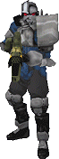 | Name:  Model:  Health:  Team:  Weapon:  Has:  Drops: | F_Eb47  elite_med_3  125  Syndicate  w7_scc  1 ammo  1 ammo
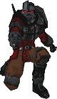 | Name:  Model:  Health:  Team:  Weapon: | F_Er59  elite_hard_3  150  Syndicate  w1_tap |  | Name:  Model:  Health:  Team:  Has: | F_Nr60  ninja_hard_2  94  Syndicate  1 shield
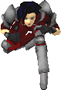 | Name:  Model:  Health:  Team:  Drops: | F_R61  red_hard_1  75  Syndicate  1 cell | 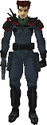 | Name:  Model:  Health:  Team:  Weapon:  Has:  Drops:  Hit Func:  Lose Func: | F_C62  comguy_1  44  Syndicate  w2_sap  2 ammos  1 hypo  1 ammo  comalarm  com_ok
 | Name:  Model:  Health:  Team:  Hit Func: | A_Sb63  striker_med_2  88  Syndicate  run1 | 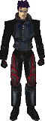 | Name:  Model:  Health:  Team:  Has:  Lose Func: | Muro  muro_generic  312  Syndicate  1 cell  1 ammo  check_death2
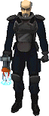 | Name:  Model:  Health:  Team:  Weapon:  Has:  Lose Func: | Griffin  griffin_swat  200  Konoko  w6_vdg  1 cell  swat_dies | 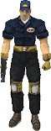 | Name:  Model:  Health:  Team:  Weapon:  Has: | shooter_dummy  thug_wh_1  1281  Syndicate  w2_sap  100 cells  100 ammos
 | Name:  Model:  Health:  Team: | target_dummy  thug_wh_1  1281  Syndicate |  | Name:  Model:  Health:  Team:  Weapon: | D_E83  elite_hard_3  150  Syndicate  none
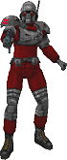 | Name:  Model:  Health:  Team:  Weapon: | A_E5b  striker_med_3  56  Syndicate  w2_sap | 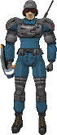 | Name:  Model:  Health:  Team:  Weapon: | A_E3b  striker_med_2  69  Syndicate  w4_psm
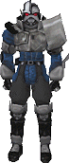 | Name:  Model:  Health:  Team: | A_E6  elite_med_3  125  Syndicate | 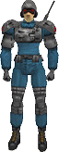 | Name:  Model:  Health:  Team: | C_b74  striker_med_2  69  Syndicate
 | Name:  Model:  Health:  Team: | C_Eb73  elite_med_1  125  Syndicate |  | Name:  Model:  Health:  Team: | C_Sb75  striker_med_3  56  Syndicate
 | Name:  Model:  Health:  Team: | C_Sb76  striker_med_3  88  Syndicate | 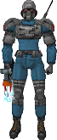 | Name:  Model:  Health:  Team:  Weapon: | C_Sb77  striker_med_1  69  Syndicate  w6_vdg
 | Name:  Model:  Health:  Team:  Weapon:  Drops: | C_Sb78  striker_med_1  69  Syndicate  w6_vdg  1 hypo | 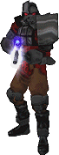 | Name:  Model:  Health:  Team:  Weapon:  Lose Func: | C_Er79  elite_hard_2  150  Syndicate  w8_mbo  music_stop
 | Name:  Model:  Health:  Team:  Weapon:  Has: | new_2  sniper_generic  38  Syndicate  w8_mbo  10 ammos | 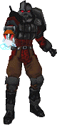 | Name:  Model:  Health:  Team:  Weapon: | F_Er86  elite_hard_3  150  Syndicate  w6_vdg
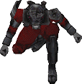 | Name:  Model:  Health:  Team: | F_Nr87  ninja_hard_3  81  Syndicate | 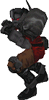 | Name:  Model:  Health:  Team: | F_Er88  elite_hard_3  150  Syndicate
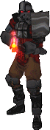 | Name:  Model:  Health:  Team:  Weapon:  Drops: | F_Er89  elite_hard_2  150  Syndicate  w3_phr  1 hypo |  | Name:  Model:  Health:  Team:  Has:  Lose Func: | GrifElite04  elite_hard_2  150  Syndicate  1 ammo  final_round
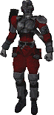 | Name:  Model:  Health:  Team:  Has: | GrifElite06  ninja_hard_1  81  Syndicate  1 cell  1 ammo |  | Name:  Model:  Health:  Team:  Drops:  Lose Func: | GrifOps01  TCTF_swat_blackops_1  90  Konoko  1 hypo  swat_dies
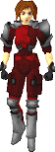 | Name:  Model:  Health:  Team:  Lose Func: | GrifElite02  red_hard_3  138  Syndicate  check_death1b |  | Name:  Model:  Health:  Team:  Has:  Lose Func: | GrifElite05  elite_hard_1  150  Syndicate  1 ammo  final_round

Table of contents

